Holiday Bazaar

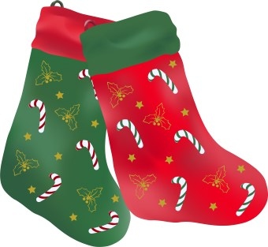

Sat., Nov. 23rd, 2024

Libertytown Fire Hall

8:00 am – 2:00 pm

12027 South St. Libertytown, MD 21762

Crafts, Homemade goodies, sandwiches, soups, bake table, raffles and much more…



For more information for table rentals call Mary 301-401-2824

Sponsored by

Libertytown Volunteer Fire Department Auxiliary